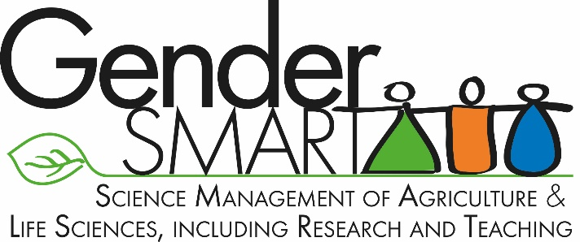**Press release**7th February 2019

**Gender-SMART | A European partnership on gender issues in agricultural and life sciences**

**Nine European partners in the Gender-SMART project, who all work in agricultural and life sciences, are under starter's orders. As part of the project, they will be putting equality in the workplace at the forefront of their operations. The issue will be addressed in terms of human resources - recruitment, career progression, governance, etc - and as an element to be included in research and teaching operations. The official kick-off meeting will be in Montpellier, from 12 to 14 February 2019.**

As the European Commission marks 20 years of policies devoted to supporting gender equality in research and innovation, CIRAD is beginning its coordination of a European project on gender in the agricultural and life sciences: Gender-SMART (Science Management of Agricultural and Life Sciences, including Research and Teaching). The project, funded by the EC Horizon 2020 programme, associates seven organizations (from Cyprus, France, Ireland, Italy, the Netherlands and Spain) and two specialist technical partners (from Belgium and the Czech Republic). *"Gender-SMART commits our organizations to setting an example between now and 2023 in terms of equality in the workplace and of including gender analysis, where relevant, in our research and teaching activities",* stresses CIRAD's Magalie Jannoyer, who is coordinating the project. *"These two aspects feed off each other and impact on the quality of our research."*

Each organization, supported by two technical partners specializing in institutional change and appraisal, has committed to develop and implement a gender equality plan, centring on four shared issues:

* Building a gender equality culture
* Developing equal career support measures
* Reshaping decision-making and governance
* Integrating gender in funding, research and teaching.

For each organization, the aim will be to adapt its action plan to its reality, taking existing inequalities and bias as its starting point and building a research and training offering that covers gender issues.

*“By involving research organizations working in the fields of agriculture and life sciences, Gender-SMART not only aims to support gender equality at each partner organization, but also to integrate the gender perspective into research content and projects, hence to act as a potential game changer in terms of addressing crucial issues* *such as climate change or food security”,* says Yellow Window's Maxime Forest.

The nine European partners will be meeting in Montpellier from 12 to 14 February 2019 to officially launch the project and prepare for the first operations, such as gender audits and evaluations at each of the partner organizations.

Gd Drapo europeen.eps**Gender-SMART is an H2020 project under the "Science with and for Society" programme. It has 3 million euros of EC funding over four years.**

**Seven organizations defining and implementing gender equality plans**:

* Agence Nationale de Recherche (France)
* Centro De Investigaciones Cientificas Y Tecnologicas De Extremadura (Spain)
* Centro Internazionale Di Alti studi Agronomici Mediterranei (Italy)
* CIRAD (France)
* Teagasc - Agriculture And Food Development Authority (Ireland)
* Cyprus University of Technology (Cyprus)
* Wageningen University and Research (the Netherlands)

**Two technical partners specializing in gender:**

* Yellow Window (Belgium)
* Institute Of Sociology Of The Academy Of Sciences Of The Czech Republic Public Research

**Contact**

Magalie Jannoyer  
CIRAD, Montpellier  
E-mail: [magalie.jannoyer@cirad.fr](mailto:magalie.jannoyer@cirad.fr)

[presse@cirad.fr](mailto:presse@cirad.fr)

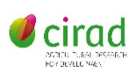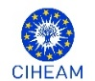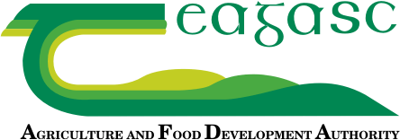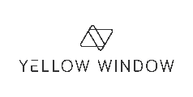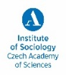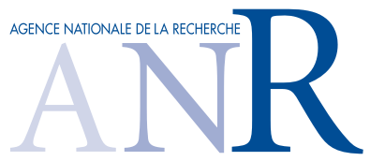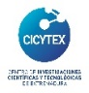

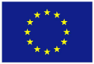 *This project has received funding from the European Union’s Horizon 2020 research and innovation programme under grant agreement No 824546.*